Run file (Assuming pip and python are installed)

* Download yolo weights from : <https://pjreddie.com/media/files/yolov3.weights> (This will take quite some time)
* Place the downloaded file in the github downloaded folder (<https://github.com/Hira172/Sp17_bcs_comsats-Project>)
* Now open command prompt and navigate to that folder then run following commands (assuming you have python and pip installed)
* pip install -r requirements.txt
* python try2.py

To install python and pip

* download installer <https://www.python.org/downloads/>
* Must check both boxes

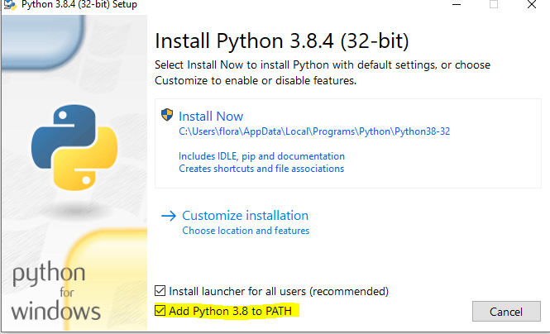

* Then install now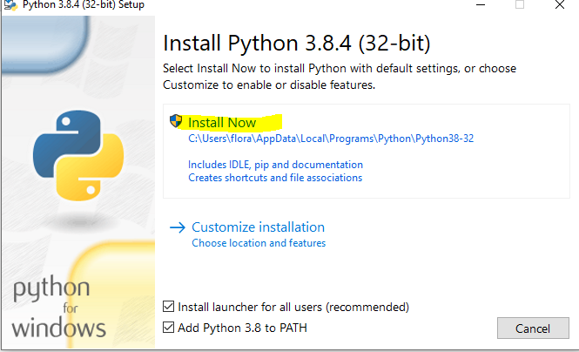
* To check run “python –version ” on command prompt
* Download <https://bootstrap.pypa.io/get-pip.py>
* Open Command prompt and navigate to the folder where you download the above file
* Then run “python get-pip.py”
* To check run “pip -V”
* Now follow the above steps to run the file